**GAP Errors**

* More than one document is not showing in Plant Protection Product.

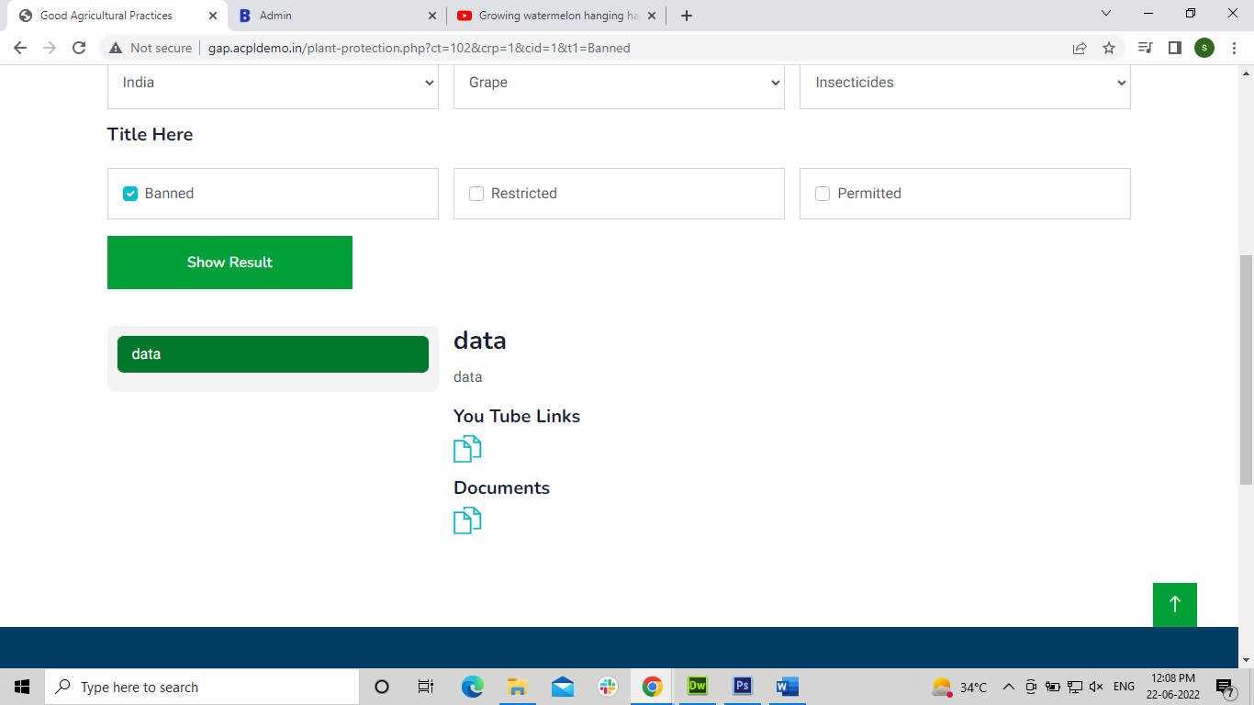

* Documents are not showing in view list in Plant Nutritional Management.

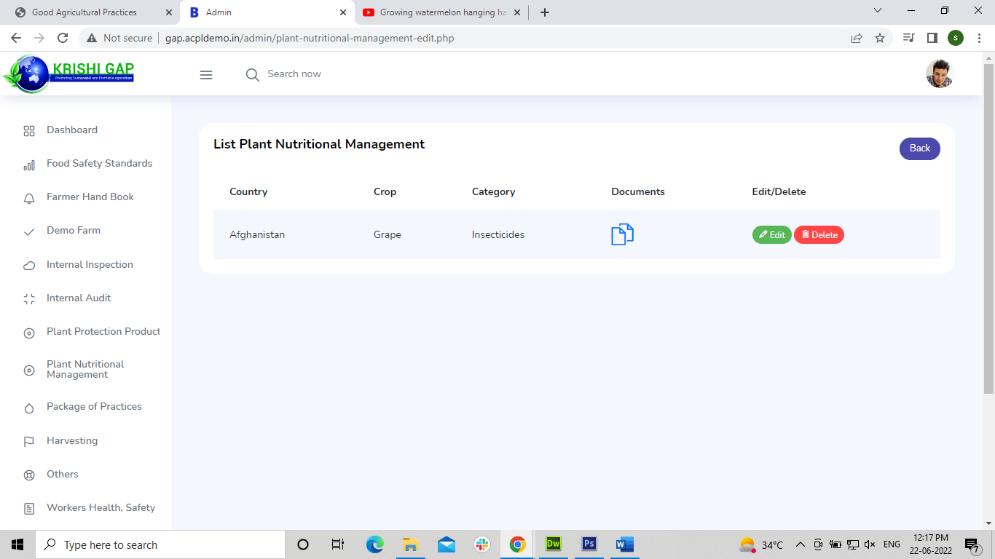

* More than one document is not showing in Plant Nutritional Management.

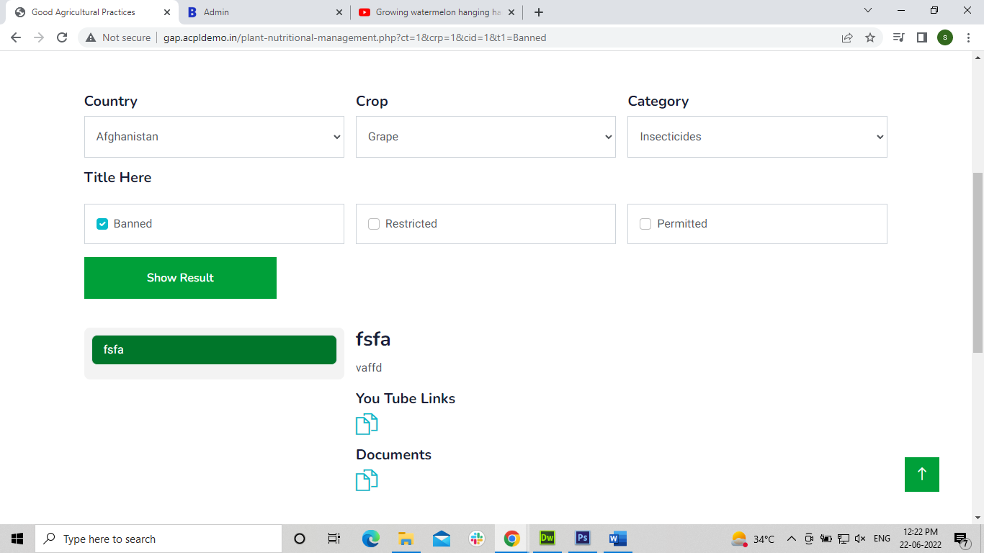

* More than one document is not showing in Package of Practices.

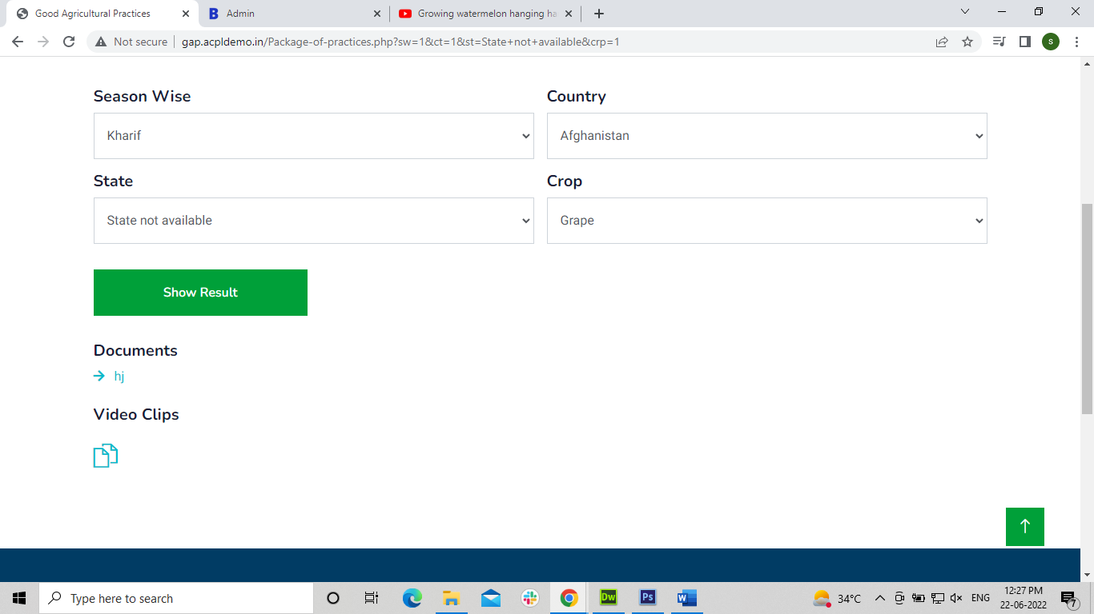

* There is showing wrong no of files in view list in Workers Health, Safety & Welfare.

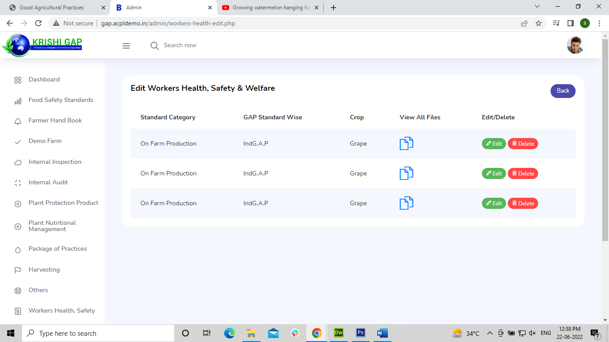

* More than one document is not showing in Workers Health, Safety & Welfare.

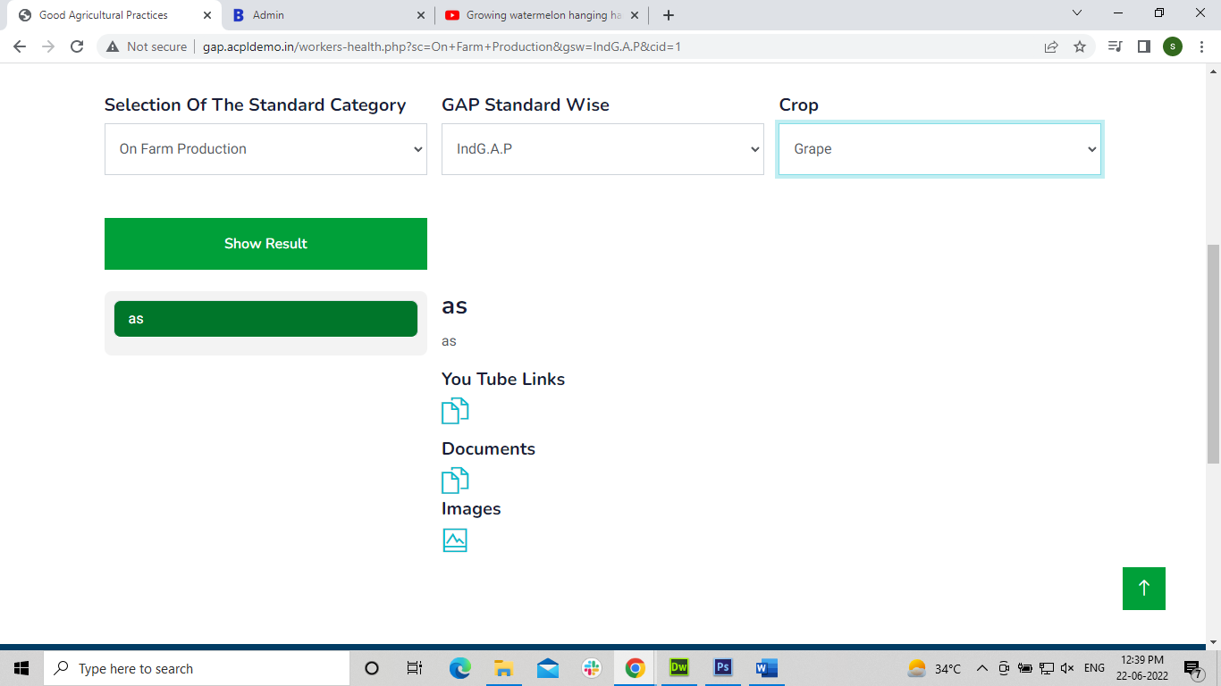

* Data is mismatch.

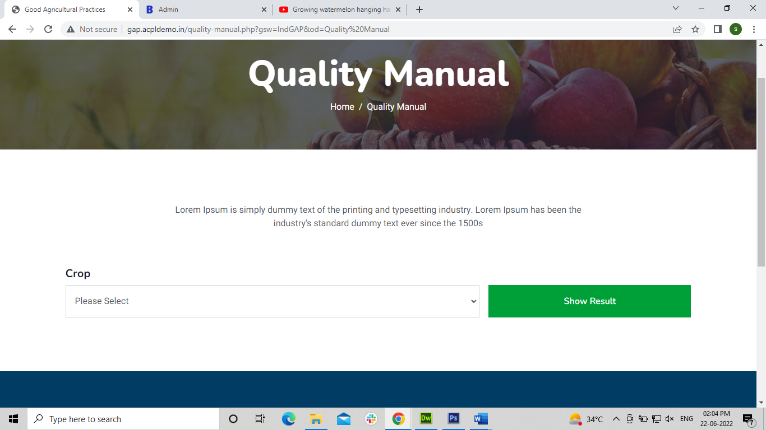

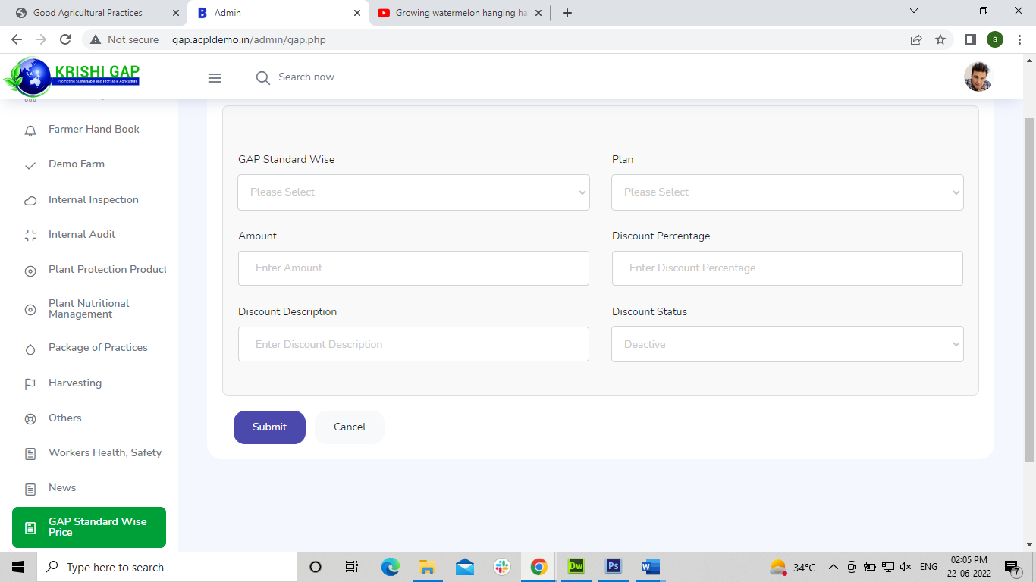

* Details are not showing.

